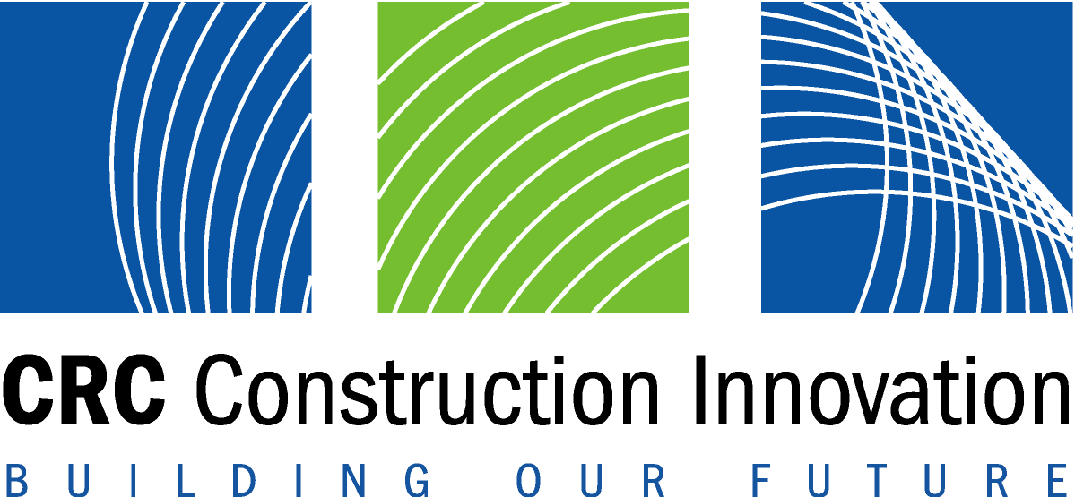

Media Release
23 September 2003

Traditional, tried and tested:
communication confronted

Cooperative Research Centre for Construction Innovation researchers are launching a national web-based survey instrument at the end of September 2003 to examine the up-take and barriers to implementing information and communication technology (ICT) in the architectural, engineering and construction industry (AEC).

Today’s AEC is facing huge challenges, culturally, economically and globally. But the new instrument, titled ‘ICT in Construction-Team Member Perspective’, aims to identify and dissect those challenges by looking at the human and cultural factors affecting limitations, barriers, and drivers across the AEC sector.

Supporting the launch of the survey instrument, the research project has produced a ‘State of the Art Report into the use of Internet-based Construction Project Management (ICPM) in the Construction Industry’. This report provides a comprehensive ‘snapshot’ of current industry practices, culture and research directions in the implementation and application of innovative ICT tools and systems.

The Queensland Department of Main Roads (QDMR) and Public Works (QDPW) are two leading partner organisations involved in and supporting the activities of this research project.

Mr Geoff Caldwell, Principal Engineer in the Delivery Systems Improvement Unit, Capability and Delivery Division of QDMR, says QDMR is currently making best use of ICT systems for works delivery in their operations.

“Through this research project however, QDMR is expecting to gain an appreciation of current industry practices and research in the use of advanced ICT's, including lessons learnt to achieve their successful implementation,” Mr Caldwell said.

Dr Stephen Kajewski, Research Project Leader, says the use of tools such as e-tendering, e-commerce and e-archiving will soon be commonplace in industry.

“This will force virtually every business sector to shift away from traditional, tried and tested methods of communications, thereby effectively revolutionising the way companies trade and conduct business,” he said.

Mr Caldwell says they are ready for the revolution.

“Advanced electronic communication will be a significant enabling technology in providing more effective and efficient delivery of roadwork projects”, Mr Caldwell said.

In an attempt to support overall improvements in AEC communication and construction management processes, the Construction Innovation research project is also:

- identifying and examining the potential use and benefits of existing and emerging hand-held technologies and applications - not yet embraced by the AEC industries.
- determining the AEC’s current state-of-play concerning e-tendering, by ascertaining the barriers and enablers from both a technological and end-user perspective
- undertaking a number of scoping and evaluation studies to facilitate development of a coherent Construction Innovation research and development agenda
- developing ‘best practice’ recommendations to assist in the adoption of innovative ICT solutions with AEC industry organisations and project teams.

Dr Keith Hampson, CEO of Construction Innovation, says this research is very important.

“It will enable us to discover what it is that can bring about a faster, more comprehensive and more efficient uptake of ICT solutions in the AEC industry,” he said.

This Construction Innovation research project is further supported by Queensland University of Technology (QUT); CSIRO – Manufacture and Infrastructure Technology, Construction Research Alliance (CRA); and the University of Newcastle.

- ENDS -

More information

Dr Stephen Kajewski, Research Project Leader, QUT, T: 3864 2676
Dr Keith Hampson, CEO, CRC for Construction Innovation T: 07 3864 1393

Media Inquiries

Kate Finlayson, Communications Officer, T: 07 3864 9295

The Cooperative Research Centre for Construction Innovation is a collaboration involving 19 industry, government and research partners and has been made possible through a $14 million Federal Government grant through the CRC Program complemented by $50 million of cash and in-kind support from industry, research and other government partners. For more information, please visit our website www.construction-innovation.info

